Kartik Padave

A022

70362019039

Experiment 2

**Aim**

To implement Monoalphabetic Cipher.

**Theory**

A monoalphabetic cipher is any cipher in which the letters of the plain text are mapped to cipher text letters based on a single alphabetic key. Examples of monoalphabetic ciphers would include the Caesar-shift cipher, where each letter is shifted based on a numeric key, and the atbash cipher, where each letter is mapped to the letter symmetric to it about the center of the alphabet.

**Code**

def decrypt(char):

    for i in cipher:

        if cipher[i] == char:

            return i

cipher = {

    'a': 'm',

   'b': 'n',

   'c': 'b',

   'd': 'v',

   'e': 'c',

   'f': 'x',

   'g': 'z',

   'h': 'a',

   'i': 's',

   'j': 'd',

   'k': 'f',

   'l': 'g',

   'm': 'h',

   'n': 'j',

   'o': 'k',

   'p': 'l',

   'q': 'p',

   'r': 'o',

   's': 'i',

   't': 'u',

   'u': 'y',

   'v': 't',

   'w': 'r',

   'x': 'e',

   'y': 'w',

   'z': 'q',

   ' ': ' '

}

plain_text = input("Enter plain text: ")

cipher_text = ""

for i in range(len(plain_text)):

    char = plain_text[i]

    if char.isupper():

        char = char.lower()

        cipher_word = cipher[char].upper()

    else:

        cipher_word = cipher[char]

    cipher_text += cipher_word

print("\nEncryption:\n")

print(f"Plain Text: {plain_text}")

print(f"Cipher text: {cipher_text}")

plain_text = ""

for i in range(len(cipher_text)):

    char = cipher_text[i]

    if char.isupper():

        char = char.lower()

        plain_word = decrypt(char).upper()

    else:

        plain_word = decrypt(char)

    plain_text += plain_word

print("\nDecryption:\n")

print(f"Cipher text: {cipher_text}")

print(f"Plain Text: {plain_text}")

**Output**

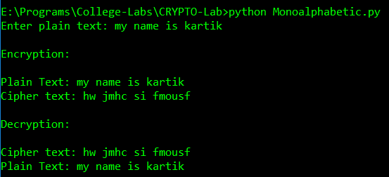

**Conclusion**

Hence, we were able to perform Monoalphabetic Cipher.